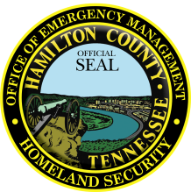
Hamilton County
Office of Emergency Management & Homeland Security

Director, Chris Adams

Contact: Amy Maxwell
Public Relations Manager
(423) 209-6900 or (423) 595-6939
amym@hamiltontn.gov

Date: October 1, 2021

Re: Fire Prevention Week – October 3 – 9, 2021

HAMILTON COUNTY, TN --- The National Fire Protection Agency (NFPA) announces Fire Prevention Week in October 3 – 9, 2021 and Hamilton County Office of Emergency Management urges everyone to test their smoke alarms and practice their escape plan in the event of a house fire. This year’s theme is “Learn the Sounds of Fire Safety”. This theme puts a focus on educating kids and adults about smoke alarms and carbon monoxide alarms sound different from each other and save lives.

“House fires haven’t stopped during this pandemic and neither has the need to prevent fire tragedies. During Fire Prevention week, test your smoke alarms and practice your family escape plans to help protect you and your family,” says HCOEM Director Chris Adams.

According to a NFPA report, working smoke alarms reduce the risk of dying in a fire by more than half.

Thanks
Amy
###

